ANSWERS(ASSIGNMENT 4)

1)We can use the command
“grep “” /etc/passwd|cut -d -f1|tee usernames.txt”
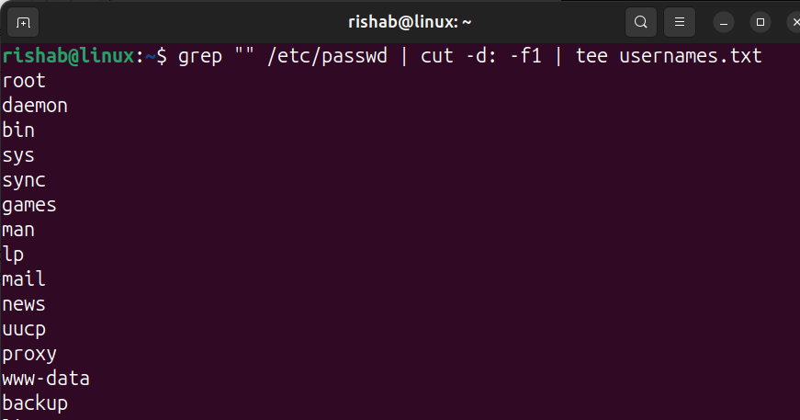
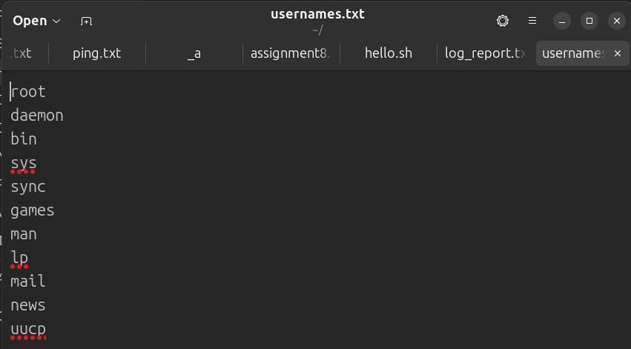

We can also use the “awk” command which is used to extract particular data.
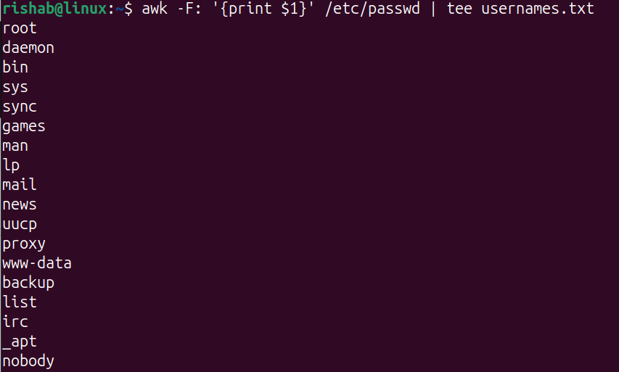

2)By using “which” command we can check whether binary is in $path
“which program_name”

We can search manually also by using the command
“find/-name program_name 2>/dev/null”

We can use “locate” command
“locate program_name”

Once found, add its directory to $path by using
“export PATH=$PATH:/path/to/binary”

3)The command is “find /var/log “*.log” -mtime -1|tee log_report.txt”
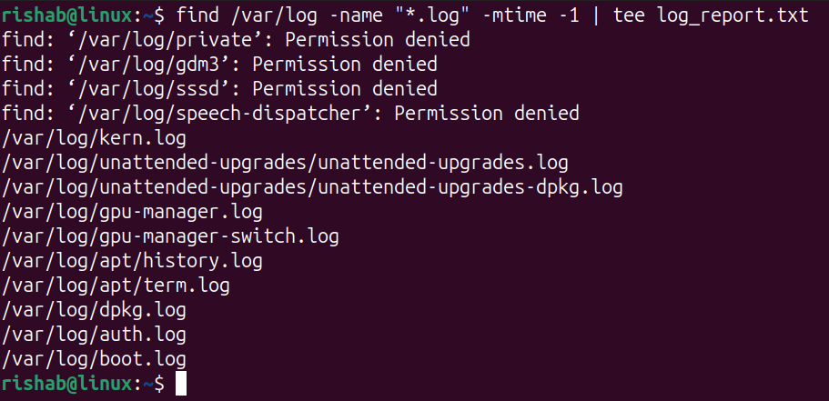
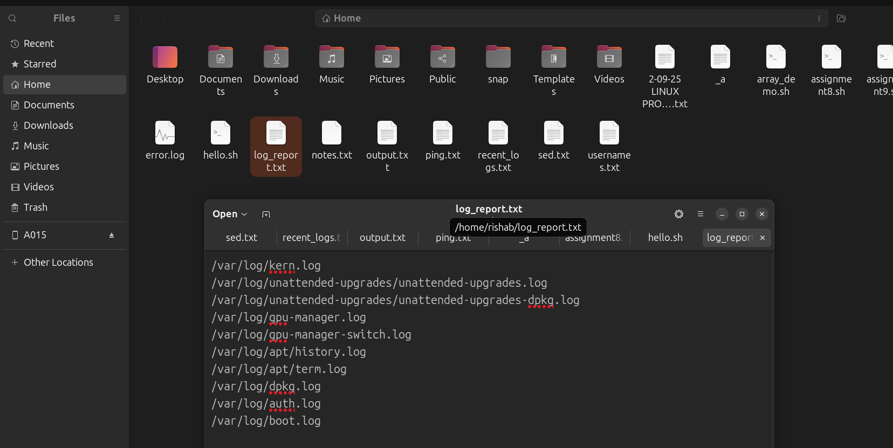

4)SHUTDOWN -R NOW
- Gracefully stops all processes and restarts the system immediately.
- We use this when we need a controlled reboot ensuring service stops safely.
REBOOT
- Directly triggers a system reboot(faster but less controlled).
- When the system is stable and you want a quick restart.

5)Suppose we take the script which needs to be debugged as “myscript.sh”
The command is “./myscript.sh 2>&&1|tee debug.txt”

6)Applications of Linux:
- Web servers: Linux powers most servers such as google, Facebook etc.
- Cloud computing: Used in AWS, Azure, GCP–stable, scalable and open-source base for virtualization.
- Embedded systems & IoT: Runs on devices like routers, android phones, and smart TV’s.

7)APPLICATION SOFTWARE
- Performs user tasks.
- For example LibreOffice, Firefox, IMP.
SYSTEM SOFTWARE
- Manages hardware and system resources.
- Linux kernel, systemd
UTILITY SOFTWARE
- Provides maintenance and system support.
- tar, grep, top, rsync.

8)OPEN-SOURCE OS
- Freely available for modification.
- Usually free of cost
- Fully customizable.
- Linux, ubuntu, fedora
- They have community and commercial like redhat

PROPRIETARY OS
- Closed and owned by company.
- Usually paid and licensed
- Limited customization.
- Windows, macOS
- Official vendor support
9)The command to display system’s kernel version is
“Uname -r”
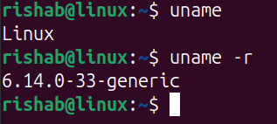
10)TAIL COMMAND

The tail command is used to display the last part of files. Its particularly useful for viewing the end of log files or any file that is being updated in real-time.

USE CASES
- Monitoring server logs to detect issues in real-time.
- Checking the latest entries in a continuously updated file.
- Debugging applications by reviewing recent log entries.

HEAD COMMAND

The head command is used to display the first part of files. Its particularly useful for previewing the start of a file to understand its structure.

USE CASES
- Preview the start of a file to understand its structure.
- Quickly check the contents of a file without opening it fully.
- Extract the header information from a data file.

